General Pivot Point Rotation or Rotation about Fixed Point:

For it first of all rotate function is used. Sequences of steps are given below for rotating an object about origin.

1. Translate object to origin from its original position as shown in fig (b)
2. Rotate the object about the origin as shown in fig (c).
3. Translate the object to its original position from origin. It is called as reverse translation as shown in fig (d).

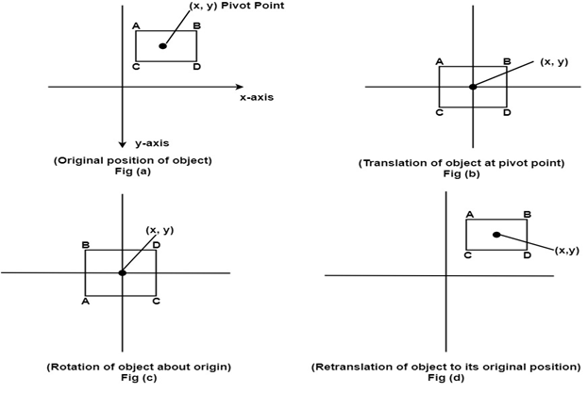

The matrix multiplication of above 3 steps is given below

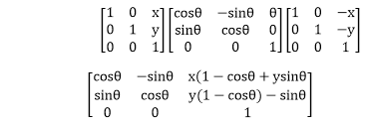

Scaling relative to fixed point:

For this following steps are performed:

**Step1:** The object is kept at desired location as shown in fig (a)

**Step2:** The object is translated so that its center coincides with origin as shown in fig (b)

**Step3:** Scaling of object by keeping object at origin is done as shown in fig (c)

**Step4:** Again translation is done. This translation is called as reverse translation.

